**Lab 2 : Constraints in the E/R Model**

**We have the database consist of 5 relations:**

Product (ProductCode, Name, PurchasePrice, SellPrice, Type, SupplierCode)

Supplier (SupplierCode, SupplierName, Address)

Employee (EmloyeeID, FullName, Gender, BirthDate, Address)

Invoice (InvoiceID, SellDate, EmployeeID)

InvoiceLine(ProductCode, InvoiceID, Quantity)

**Exercise 1: Draw an ER model corresponding to the database above**

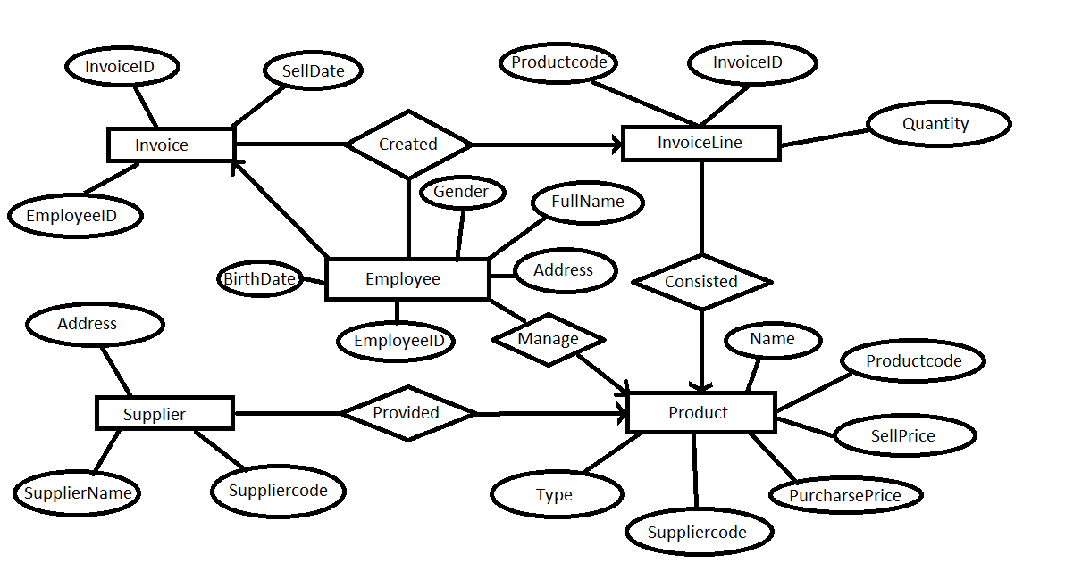

**Exercise 2: Use Relational Algebra to express following constraints:**

1. The sell price must be higher than the purchase price.

F: $σ(SellPrice≤PurchasePrice)(Product)$ = ∅

1. A product of Samsung must be television, mobile or tablet.

R1 = Product ⋈ Supplier

$F:σ$ SupplierName <> “Samsung” and ( Type <> “television” and Type <> “mobile” and Type <> “tablet”) (R1) = ∅

1. No supplier of mobile’s or tablet’s may also supply food.

$F:σ$ Supplier(type!=mobile && type!=tablet) || supplier(type!=food) = ∅

$Sửa: σ(Type=mobile" \&\& type="tablet" \&\& type="food"$) (product join supplier) = ∅

$Sửa 2: σ (\left(Type =\text{mobile}\&\& Type=\text{food}\right)or (Type=\text{tablet \&\& Type = "}\text{food}\text{"))(Product )= }$ ∅

Sửa 3: $R=Product join Supplier$

R1 =chiếu SupplierCode(Select Type =Mobile or Type = “tablet”)®

R2 =chiếu SupplierCode(SelectType = “food”)®

R1 giao R2 = ∅

No product may appear more than one time in an invoice.

1. The quantity of each product in each invoice should be greater than 0.

F : $σ$ Quantity <= 0 (InvoiceLine)

1. There is no invoice without product.

F: InvoiceID <> null and ProductCode = null(InvoiceLine)

1. If purchase price is less than 500.000 VND, the sell price could not be greater than 9.000.000 VND.

**F : $σ\left(PurchasePrice<500000 and SellPrice>9000000\right)\left(Product\right)$**

1. The sell price could not be greater than 2 times the purchase price.

T: $σ$**(**SellPrice <= (PurchasePrice * 2)) (Product) $=$ ∅

F: $σ ( SellPrice>\left( PurchasePrice*2\right)\left(Product\right)=$ ∅

1. The gender of an employee should be “Male” or “Female”.

T: $σ$ (Gender= ‘Male’ or Gender ‘Felmale’)(Employee)

$F:σ \left(Gender><^{'}{Male}^{'}or Gender><Female^{'}\left(Employee\right)\right)=$ ∅

1. With the same purchase price, the sell price of two products could not have the difference more than 0.5 times of the purchase price.

R1:= p(Product)

R2:= p(Product)

**F : $σ\left(R1.PurchasePrice=R2.PurchasePrice and\left(R1.SellPrice-R2.SellPrice\right)>0.5*R1.PurchasePrice\right)\left(R1*R2\right)=$**∅